***Problem:***

Maria plays  games of college basketball in a season. Because she wants to go pro, she tracks her points scored per game sequentially in an array defined as . After each game , she checks to see if score  breaks her record for most or least points scored so far during that season.

Given Maria's array of  for a season of  games, find and print the number of times she breaks her record for *most* and *least* points scored during the season.

**Note:** Assume her records for most and least points at the start of the season are the number of points scored during the first game of the season.

**Input Format**

The first line contains an integer denoting  (the number of games).   
The second line contains  space-separated integers describing the respective values of .

**Constraints**

**Output Format**

Print two space-seperated integers describing the respective numbers of times her best (highest) score increased and her worst (lowest) score decreased.

**Sample Input 0**

9

10 5 20 20 4 5 2 25 1

**Sample Output 0**

2 4

**Explanation 0**

The diagram below depicts the number of times Maria broke her best and worst records throughout the season:

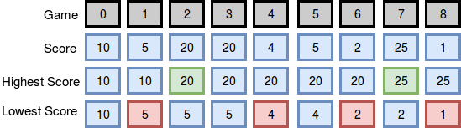

She broke her best record twice (after games  and ) and her worst record four times (after games , , , and ), so we print 2 4 as our answer. Note that she *did not* break her record for best score during game , as her score during that game was *not* strictly greater than her best record at the time.

**Sample Input 1**

10

3 4 21 36 10 28 35 5 24 42

**Sample Output 1**

4 0

**Explanation 1**

The diagram below depicts the number of times Maria broke her best and worst records throughout the season:

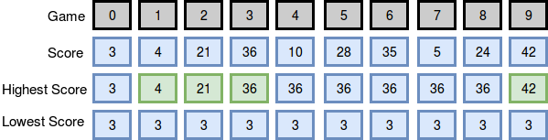

She broke her best record four times (after games , , , and ) and her worst record zero times (no score during the season was lower than the one she earned during her first game), so we print 4 0 as our answer.

***Solution:***

int main() {

/* Enter your code here. Read input from STDIN. Print output to STDOUT */

int games;

int max=0, min=0;

int breakMax=0, breakMin=0;

cin>>games;

long scores[games];

//long * scores = new long[games];

/*Feeding the data*/

for(int i=0; i<games; i+=1)

{ cin>>scores[i];

if(i==0)

{

max=scores[i];

min=scores[i];

}

else

{

if(scores[i] > max) { breakMax+=1; max=scores[i]; }

//Increement counter if the max score record is broken

if(scores[i] < min) { breakMin+=1; min=scores[i]; }

//Increement counter if the min score record is broken

}

}

cout <<breakMax <<" " <<breakMin;

return 0;

}